Chapter 7, Problem 80.

In the circuit of Fig. 7.144, assume that the switch has been in position a for a long time, find:
- i₁(0), i₂(0), and v₀(0)
- i_{L}(t)
- i₁(∞), i₂(∞), and v₀(∞)

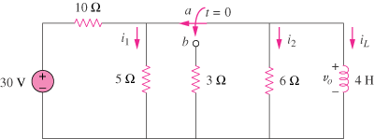

Figure 7.144
For Prob. 7.80.

